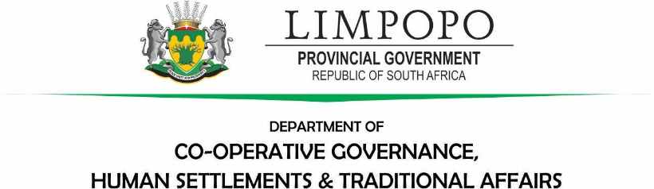

Immediate Release

25 November 2024

Attention: All Media Houses.

MEC Makamu to visit families hit by heavy rains and thunderstorms under Collins Chabane Local Municipality.

The MEC for Co-operative Governance, Human Settlements and Traditional Affairs (CoGHSTA), Mr Basikopo Makamu will visit the families that were severely hit by recent heavy rains and thunderstorms in Collins Chabane Local Municipality. The weather conditions in the area were classified under yellow level 2 by the South African Weather Service.The aftermath of the heavy winds and rainfall left 36 houses damaged in Mtititi, Jilongo, New Orleans and Govhu villages leaving victims destitute. MEC Makamu will visit wards 35 and 36 to assess the magnitude and impact of the yellow level 2 thunderstorms.

The visit will take place as follows:

Date:Wednesday, 27 November 2024

Venue: Collins Chabane Local Municipality

Time: 14:00

For more information contact: Mr Molebatsi Masedi, MEC Spokesperson on 066 477 8919 or Ms Tsakani Baloyi (Director-Communications) on 066 486 2571.